Camunda 8 SaaS + Spring Boot — Student Leave Workflow Lab

What students build
Students build a Student Leave Application process that runs on a Camunda 8 SaaS cluster, with all the business logic in a Spring Boot app on their laptop. It covers the four things every Camunda 8 + Spring project needs: deploying a model from code, starting an instance over REST, running service tasks as job workers, and a human task in Tasklist.
The process logic:
- A student submits a leave request through a REST call (POST /leave).
- Validate leave request (Java worker) computes the number of days and checks the dates are not in the past.
- A gateway routes the request: invalid dates are rejected, up to 2 days is auto-approved, more than 2 days goes to the Faculty Advisor approval form in Tasklist.
- Notify student (Java worker) logs the final decision (stand-in for an e-mail).
The app talks to the cluster outbound only, so it works from a campus network or home Wi-Fi with no port forwarding. The cluster never calls the laptop; workers poll it for jobs.
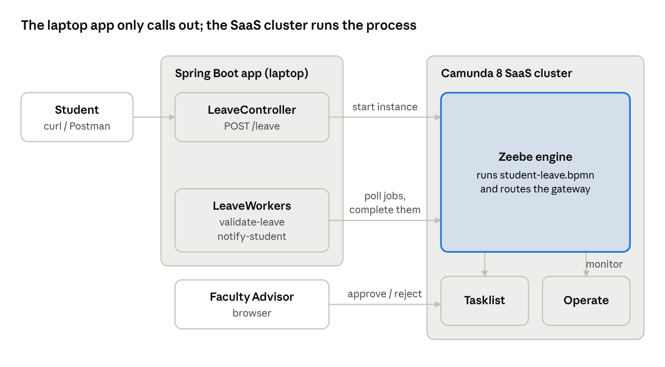
lab architecture · laptop app and SaaS cluster
Every arrow from the laptop points outward: the controller starts instances and the workers fetch jobs, so no inbound port is needed.

Step-by-step lab sheet (the whole lab on one page)
Students follow these 16 steps in order; Parts A–D below explain each one.
In Camunda Cloud (browser)
- Log in to console.camunda.io.
- Clusters → Create new cluster → name leave-demo, nearest region, 8.8 → Create. Wait for Healthy.
- Open the cluster → API tab → Create new client → name leave-app, tick the Zeebe / Orchestration Cluster scope.
- Copy Client ID, Client Secret, Cluster ID and Region (Spring Boot tab). Save them safely.
- Open Modeler → New project Leave Workflow → Upload student-leave.bpmn and fa-approval.form (or draw them, Part B).
- Click the process canvas and confirm Process ID = student-leave; click each service task and confirm the task types validate-leave and notify-student.
On the laptop (IDE)
- Unzip leave-workflow.zip and open it in IntelliJ / VS Code as a Maven project.
- Paste the four values from step 4 into src/main/resources/application.yaml.
- Read LeaveWorkers.java: match each @JobWorker(type=…) to a service task.
- Read LeaveController.java: note bpmnProcessId("student-leave").
- Run mvn spring-boot:run. Check the log for the deployment and "started" lines.
Test (browser + terminal)
- Operate → Processes: confirm Student Leave Application is deployed.
- Send a 2-day request with curl/Postman → instance completes → log shows APPROVED.
- Send a 5-day request → Operate shows the token waiting at Faculty Advisor approval.
- Tasklist → open the task → Assign to me → tick Approve, add remark → Complete.
- Operate → open the instance → show the path taken and the Variables panel. Take screenshots for the record.
Project files: leave-workflow.zip (shared alongside this guide) contains the full Maven project, the BPMN model and the form.

Prerequisites
Item | Version / note
Camunda account | Free trial or university/team org at console.camunda.io
JDK | 17 or later (java -version)
Maven | 3.9+ (mvn -v), or use the IDE's bundled Maven
IDE | IntelliJ IDEA Community or VS Code with Java extensions
HTTP client | Postman, or curl in a terminal
The project pins Spring Boot 3.5.6 with camunda-spring-boot-starter 8.8.15. This starter replaced the older Spring Zeebe SDK from Camunda 8.8 onward, so older tutorials using spring-boot-starter-camunda-sdk or ZeebeClient are out of date. Set camunda.version in pom.xml to the same minor version as your cluster (shown in Console).

Part A — Camunda Console: cluster and API client
The goal of Part A is four values: Client ID, Client Secret, Cluster ID and Region. Everything else in the app is fixed.
- Sign in at console.camunda.io.
- Open Clusters → Create new cluster. Name it (e.g. leave-demo), pick the nearest region and the 8.8 generation, then create. Wait until the status shows Healthy (a few minutes).
- Open the cluster and go to the API tab → Create new client.
- Name the client leave-app and tick the Zeebe / Orchestration Cluster scope. Create it.
- A dialog shows the credentials once. Switch to its Spring Boot tab: it prints a ready-made camunda.client block. Copy it, or download the credentials file.
- Keep the secret private: never commit it to GitHub. Each group should create its own client.
If the secret is lost, delete the client and create a new one; it cannot be shown again.

Part B — Web Modeler: the process and the form
Students can either import the two files from the zip (fast) or draw them (better for learning). The IDs below must match the Java code exactly.
Option 1 — import: In Modeler, create a project Leave Workflow, then Upload files and pick student-leave.bpmn and fa-approval.form from src/main/resources/bpmn/.
Option 2 — draw it yourself:
- Create a BPMN diagram. Click empty canvas and set ID = student-leave, Name = Student Leave Application.
- Start event "Leave requested" → Service task "Validate leave request". Under Task definition, set Type = validate-leave.
- Add an exclusive gateway with three outgoing flows and these Condition expressions:
  - to the merge gateway: =valid and leaveDays <= 2
  - to the user task: =valid and leaveDays > 2
  - to the merge gateway: =not(valid)
- User task "Faculty Advisor approval". Choose Camunda user task, then Form → Link to form and pick the form from step 7 (form ID fa-approval-form).
- A second exclusive gateway merges the three paths → Service task "Notify student" with Type = notify-student → End event.
- Check the Problems panel is empty.
- Create a Form with ID fa-approval-form: a Text view showing {{studentName}}, {{regNo}}, dates and reason; a Checkbox with key approved; a Text area with key remarks.
In the model | Value | Must match in code
Process ID | student-leave | bpmnProcessId("student-leave") in LeaveController
Task type | validate-leave | @JobWorker(type = "validate-leave")
Task type | notify-student | @JobWorker(type = "notify-student")
Form ID | fa-approval-form | file name in @Deployment
Form field keys | approved, remarks | @Variable names in notifyStudent
No need to click Deploy in Modeler: the Spring Boot app deploys both files on start-up. If students drew their own model, they export it (Download) into src/main/resources/bpmn/ with the same file names.

Spring Boot project from scratch (for the student question)
For their own question, students create a new Spring Boot project instead of unzipping one. It takes about 10 minutes.
- Open start.spring.io (Spring Initializr). Choose: Project Maven, Language Java, Spring Boot 3.5.x, Java 17.
- Metadata: Group edu.srmist, Artifact outpass-workflow, Package name edu.srmist.outpass, Packaging Jar.
- Dependencies → Add → Spring Web. Click Generate; unzip the download.
- Open the folder in IntelliJ (File → Open → pick pom.xml → Open as Project) or VS Code. Wait for Maven to finish downloading.
- In pom.xml, inside <dependencies>, add the Camunda starter (same block as Step C1, version 8.8.x). Reload Maven (IntelliJ: the floating M icon).
- Rename src/main/resources/application.properties to application.yaml and paste the SaaS block from Step C2 with the group's own four values.
- Create folder src/main/resources/bpmn/. Export the BPMN and the form from Web Modeler (Download) into it.
- In the main class (the one with @SpringBootApplication), add @Deployment(resources = {"classpath:bpmn/<file>.bpmn", "classpath:bpmn/<file>.form"}).
- Create package worker with a @Component class; write one @JobWorker(type = "…") method per service task.
- Create package api with a @RestController that injects CamundaClient and starts the process (copy the pattern from Step C5, change the process ID).
- Run with mvn spring-boot:run or the green ▶ button on the main class; test with curl/Postman, then check Operate and Tasklist.
Package layout students should end with:
edu.srmist.outpass
├─ OutpassWorkflowApplication.java @SpringBootApplication + @Deployment
├─ api/OutpassController.java POST /outpass
└─ worker/OutpassWorkers.java check-outpass, issue-outpass

Part C — The Spring Boot project
Unzip leave-workflow.zip and open the folder in the IDE as a Maven project. Students touch only one file (application.yaml); the rest is code to read and explain.
leave-workflow/
├─ pom.xml
└─ src/main/
├─ java/edu/srmist/leave/
│ ├─ LeaveWorkflowApplication.java (@Deployment)
│ ├─ api/LeaveController.java (POST /leave starts an instance)
│ └─ worker/LeaveWorkers.java (two @JobWorker methods)
└─ resources/
├─ application.yaml (SaaS credentials)
└─ bpmn/student-leave.bpmn, fa-approval.form
Step C1 — dependency (pom.xml). One starter brings the Camunda client, job workers and auto-deployment:
<dependency>
<groupId>io.camunda</groupId>
<artifactId>camunda-spring-boot-starter</artifactId>
<version>${camunda.version}</version>
</dependency>
Step C2 — connect to SaaS (application.yaml). Paste the four values from Part A. In saas mode the client builds the cluster URLs itself, so no address is set by hand.
camunda:
client:
mode: saas
auth:
client-id: <client id>
client-secret: <client secret>
cloud:
cluster-id: <cluster id>
region: <region, e.g. bru-2>
Each value can also come from an environment variable (CAMUNDA_CLIENT_ID, CAMUNDA_CLIENT_SECRET, CAMUNDA_CLUSTER_ID, CAMUNDA_CLUSTER_REGION), which keeps secrets out of Git.
Step C3 — deploy from code (LeaveWorkflowApplication).
@SpringBootApplication
@Deployment(resources = {
"classpath:bpmn/student-leave.bpmn",
"classpath:bpmn/fa-approval.form"})
public class LeaveWorkflowApplication { ... }
Step C4 — job workers (LeaveWorkers). The type links a method to a service task. @Variable pulls process variables in; the returned Map is written back as variables. The job completes automatically when the method returns.
@JobWorker(type = "validate-leave")
public Map<String, Object> validateLeave(@Variable String regNo,
@Variable String fromDate,
@Variable String toDate) {
LocalDate from = LocalDate.parse(fromDate);
LocalDate to = LocalDate.parse(toDate);
long days = ChronoUnit.DAYS.between(from, to) + 1;
boolean valid = days > 0 && !from.isBefore(LocalDate.now());
boolean autoApproved = valid && days <= 2;
return Map.of("leaveDays", days, "valid", valid, "approved", autoApproved);
}
@JobWorker(type = "notify-student")
public Map<String, Object> notifyStudent(@Variable String studentName,
@Variable String regNo, @Variable Boolean approved, @Variable String remarks) {
String status = Boolean.TRUE.equals(approved) ? "APPROVED" : "REJECTED";
log.info("Mail to {} ({}): your leave is {}. Remarks: {}", studentName, regNo, status, remarks);
return Map.of("leaveStatus", status);
}
Step C5 — REST trigger (LeaveController). The injected CamundaClient starts one process instance per request; the JSON body becomes the process variables.
@PostMapping("/leave")
public Map<String, Object> applyLeave(@RequestBody LeaveRequest request) {
ProcessInstanceEvent instance = camundaClient.newCreateInstanceCommand()
.bpmnProcessId("student-leave")
.latestVersion()
.variables(request)
.send().join();
return Map.of("processInstanceKey", instance.getProcessInstanceKey());
}

Part D — Run it and watch it in Operate and Tasklist
- Start the app: mvn spring-boot:run (or run LeaveWorkflowApplication from the IDE). The log should show the deployment of student-leave and the two workers opening.
- Check the deployment: Console → cluster → Operate. The Student Leave Application process now appears in the Processes list.
- Short leave (auto-approved) — dates 2 days apart, in the future:
curl -X POST http://localhost:8080/leave -H "Content-Type: application/json" -d '{"studentName":"Priya","regNo":"RA2311003010001","fromDate":"2026-10-20","toDate":"2026-10-21","reason":"Medical appointment"}'
The response returns a processInstanceKey. In Operate the instance is already Completed, and the app log prints Mail to Priya ... APPROVED.
- Long leave (needs FA) — change toDate to 2026-10-24 (5 days) and send again. In Operate the token waits at Faculty Advisor approval.
- Approve in Tasklist: Console → Tasklist → open the task → Assign to me → tick Approve this leave, type a remark → Complete task. The instance finishes and the log prints the decision with the remark.
- Invalid dates — send a fromDate in the past. The gateway takes the invalid dates path and the student is told REJECTED without FA involvement.
- In Operate, open each instance and show students the Variables panel (leaveDays, valid, approved, remarks) and the highlighted path taken through the diagram.
Postman users: method POST, URL http://localhost:8080/leave, Body → raw → JSON, same body as above.

Sample question for students: Hostel Out-Pass Request
SRM hostel students need an out-pass to leave campus. Automate the request with Camunda 8 SaaS and a Spring Boot app, using the leave example as your reference.
Process rules
- The student submits a request through POST /outpass with studentName, regNo, hostelBlock, outDate, returnDate, parentPhone, purpose.
- A service task Check request (type check-outpass) computes nights and sets valid = false if the return date is before the out date.
- A gateway: invalid → reject; nights = 0 (day out) → auto-approve; nights >= 1 → Warden approval user task with a form (approved checkbox, wardenRemarks).
- A service task Issue out-pass (type issue-outpass) creates a pass number OP-<regNo>-<outDate> for approved requests and logs "SMS to parent" with the decision.
- The process ends with the variable passStatus = ISSUED or REJECTED.
Deliverables
- BPMN file and form (exported from Web Modeler), plus the Spring Boot project zip.
- Screenshots: Operate showing one auto-approved, one warden-approved and one rejected instance; Tasklist with the warden form.
- A half-page note: which variables each worker reads and writes.
Marking scheme (10)
Component | Marks
BPMN model correct: IDs, task types, gateway conditions | 3
Job workers implemented and connected to SaaS | 3
REST endpoint starts the process | 1
Warden form linked and working in Tasklist | 1
Three test cases shown in Operate + variable note | 2
Extension (bonus 2): add a timer boundary event so that if the warden does not act in 24 hours the request is escalated to the Chief Warden.
Solution key (faculty only): outpass-workflow-solution.zip holds a working answer: hostel-outpass.bpmn, warden-approval.form, the two workers and POST /outpass. Gateway conditions: =valid and nights = 0, =valid and nights >= 1, =not(valid).
Worker | Reads | Writes
check-outpass | regNo, outDate, returnDate | nights, valid, approved (true for a day out)
issue-outpass | regNo, outDate, studentName, parentPhone, approved, wardenRemarks | passStatus, passNumber

Troubleshooting and exercises
Symptom | Likely cause and fix
401 Unauthorized / token error at start-up | Wrong client ID or secret, or the client lacks the Zeebe / Orchestration Cluster scope. Recreate the client.
UNAVAILABLE / cannot connect | Wrong cluster-id or region, or grpc-address / rest-address set by hand. In SaaS mode remove the address lines.
Instance stuck at a service task | Worker type does not match the task type in the model (check spelling and case).
Incident in Operate: "Text cannot be parsed" | Date not in yyyy-MM-dd format. Fix the variable in Operate, then Retry. A good live demo of incidents.
Expected to find process ... student-leave | Process ID in the model is not student-leave, or the app has not deployed yet.
User task has no form | Form ID not linked, or the .form file missing from @Deployment.
Old tutorial code does not compile | It uses ZeebeClient / io.camunda.zeebe.spring.*. Use CamundaClient and io.camunda.client.annotation.*.
Exercises for students (build on the same project):
- ☐ Add a timer boundary event on the FA task: escalate to the HOD after 2 days.
- ☐ Replace the log line in notify-student with a real e-mail via the SendGrid or REST connector, so the model, not Java, sends it.
- ☐ Add a leave-balance check: a worker that reads a JSON file or a small H2 table and throws a BPMN error when the balance is exhausted.
- ☐ Write a GET /leave/{key} endpoint that returns the instance status.
- ☐ Make each group adapt the pattern to their own course project (feedback analysis, OD approval, research-grant request), keeping at least one REST or script integration.

